**Linear Anode for Pipeline Rehabilitation – Thirty Years Later**

Ted Huck  
MATCOR Inc.  
101 Liberty Lane  
Chalfont, PA 18914 USA

**ABSTRACT**

This paper will detail the thirty year history of the use of linear anode anodes to protect older generation pipelines with aging coatings. The presentation will discuss the original polymeric linear anode and the product's history of evolution to today's MMO coated titanium wire anode. The paper will then discuss aging pipelines and the problem that creates for the effective application of cathodic protection. The paper will briefly discuss recoating as an option before diving into the application of linear anodes including installation methodologies and design considerations. The paper will then present some case stories and examples of successful installations.

**INTRODUCTION**

There is a long and successful history of using linear anodes to cathodically protect older generation pipelines with aging coatings. The use of linear anodes to address poor cathodic protection distribution has proven to be easier and more cost effective than large scale recoating projects. While the use of linear anodes is common in the United States, there are many similar vintage pipelines in Europe, the Middle East and Asia which struggle with the same challenges and for whom this technology should be of great interest.

**A BRIEF HISTORY OF LINEAR ANODES**

The first linear anode product appeared in the mid to late 1990s. It was a revolutionary anode concept – a flexible long length anode cable intended to operate at low current outputs. This first generation linear anode included several key features that remain the standard for today’s linear anodes: packaged sock diameter, fabric housing, and braiding to protect the fabric housing and help ensure even coke compaction. There were also some unique flaws in the first generation linear anode. The anode material itself was a conductive polymer formulation that doubled as the insulation on the anode lead wire. This dual role of anode and cable insulation was a major flaw. Notably, the use of a polymeric anode while extremely creative, was a very poor choice of anode material. The polymeric anode is subject to cracking at any area of localized high current output. Since the anode also doubled as cable insulation, when the anode cracked, the conductor was exposed and quickly went into solution yielding to an open circuit anode failure.  
  
A few years after the introduction of the polymeric based first generation linear anode, an alternate design utilizing a platinum coated wire anode combined with an internal header cable was introduced. This anode addressed two of the primary flaws in the first generation linear anode. It substituted the polymeric cable anode into a wire anode assembly and an insulated conductor assembly. Separating the anode from the internal conductor allowed for the use of higher capacity anode wires, varying the internal conductor size, and multiple redundant internal anode-to-header cable connections. With current fed from two directions, this creates a redundant current feed to the wire anode. You can cut the wire anode based linear anode into two pieces and the anode would still function being fed from each end. Platinum based catalytic anodes were quickly replaced with Mixed Metal Oxide based wire anodes as they were more cost effective, less prone to failure, allowed for a longer anode system life and a larger range of current outputs, and provided a far more robust material. This represents the second generation of linear anodes.

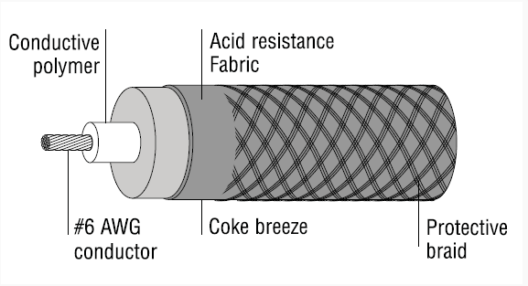

Figure First Generation Polymeric Anode

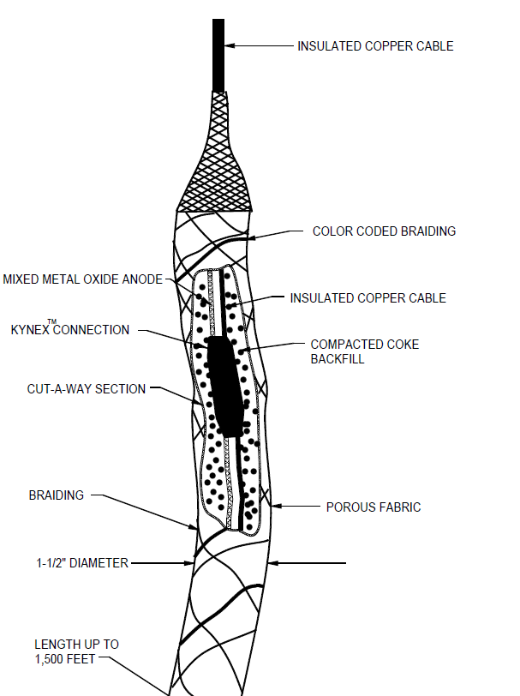

Figure Second Generation Linear Anode

Additional modifications and product enhancements including the use of automated connection technologies, the development of a pulling packaging arrangement to facilitate more difficult HDD installations, the use of sand backfill for low head space tank applications to prevent shorting, and the adaptation of the coke backfill sock assembly to a bare linear anode installed in a drilled flexible HDPE pipe for marine applications and other product variations have been introduced for specialized applications.

The second generation linear anodes utilizing MMO coated titanium wire with an internal header cable connection to the anode at multiple locations remains the current state of the art linear anode for most applications.

**AGING PIPELINES – THE PROBLEM**

Asphaltic type coatings have been popular for pipelines for several decades. The use of asphalt-based coatings for pipelines dates to the early to mid-20th century. The popularity of asphaltic coatings increased significantly in the mid-20th century due to the growth of the oil and gas industry and the expansion of pipeline infrastructure after World War II. Asphalt-based coatings were widely used for both buried and above-ground pipelines to safeguard against corrosion caused by soil conditions and environmental factors. One important feature of these asphaltic type coatings is that they typically fail in a non-shielding manner.

The lifespan or coating life of these popular asphaltic type of pipeline coatings can vary depending on several factors such as the quality of the coating material, application process, environmental conditions, and maintenance practices, but their typical lifespan can range from 20 to 40 years under favorable conditions. By the mid to late 1990s, as linear anodes were being introduced, many of these asphaltic coated pipelines were reaching or had passed the coating’s expected useful life.

As these coatings deteriorated, the cathodic protection systems were taking on an ever increasing role in corrosion prevention. Less coating means more cathodic protection current is required. However, cathodic protection for aging pipelines with poor quality coatings presents even more significant challenges compared to pipelines with intact and well-maintained coatings. Poor quality coatings can lead to accelerated corrosion and reduce the effectiveness of cathodic protection systems. This results in:

* 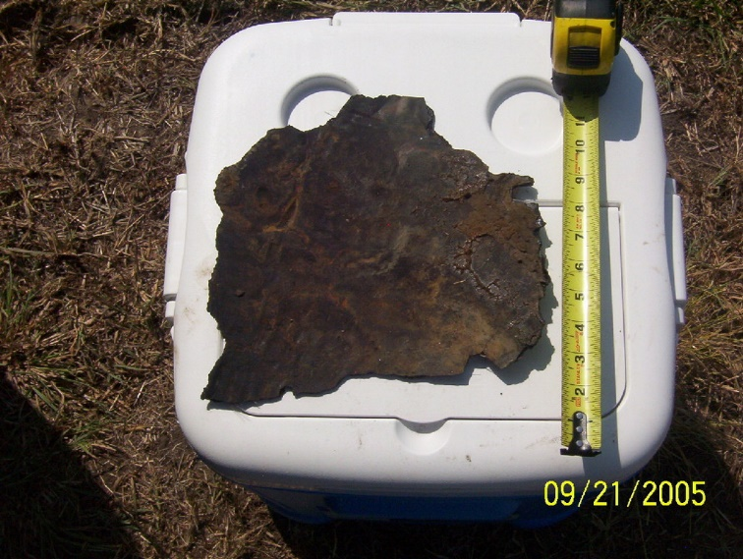Inadequate Current Distribution: Poorly coated aging pipelines with remote anode beds will have uneven current distribution, making it challenging to provide adequate cathodic protection to all areas of the pipeline. As the coating system degrades the current attenuation is greatly reduced resulting in current not distributing along the length of the pipeline leaving large areas with insufficient protection.

Figure Coating Disbondment found near Rectifier location

* Inadequate Cathodic Protection results in the application of even more current to try and push more current to distribute further along the pipeline. Additional anode beds are frequently installed because the diminished current attenuation prevents sufficient current distribution.
* Cathodic Disbondment: The presence of poor quality coatings near anode bed locations encourages cathodic disbondment. High localized cathodic protection currents cause formation of hydrogen gas at the pipeline surface that can result in more of the coating disbonding from the pipeline.

These three issues; inadequate current distribution, ineffective cathodic protection and increased levels of cathodic protection causing further coating degradation, feed off each other creating a very challenging situation that if not addressed could lead to costly pipeline failures.

**AGING PIPELINES – THE RECOAT SOLUTION**

Recoating is an expensive and complicated solution. Recoating is a very intrusive undertaking of digging up the pipeline to provide access for recoating. The original coating must be removed, and this may involve significant asbestos abatement considerations. Asbestos is a concern when dealing with older pipelines.

Asbestos fibers were often used as fillers or reinforcement in asphaltic coatings to improve their mechanical properties. The use of asbestos in coatings and other construction materials has been phased out due to the health risks associated with asbestos exposure. If the pipeline was coated with an asphaltic material containing asbestos and the coating is disturbed during the recoating process, asbestos fibers can be released into the air. Inhalation of asbestos fibers can lead to serious respiratory diseases, including mesothelioma and lung cancer.

When planning to recoat pipelines with a history of asbestos-containing coatings, it is essential to follow proper asbestos abatement procedures and hire professionals trained in handling asbestos-containing materials safely. Testing for asbestos presence in the existing coating and taking appropriate measures to contain and remove asbestos, if necessary, is crucial to protect workers and the environment.

Once the aging coating has been removed, the pipeline surface preparation must be performed in accordance with the recommendations for the new coating application. This includes controlling the temperature and humidity conditions and allowing for the appropriate curing time. Quality control and proper inspection are critical for a quality recoat.

Given the challenge, impact, and cost of a significant recoat project, it is not surprising that alternative solutions would be considered before undertaking a recoating project.

**AGING PIPELINES – THE LINEAR SOLUTION**

Linear anodes offer a unique solution to the challenges facing older pipelines with asphaltic type coatings. They can help mitigate the issue of poor coatings on aging pipelines by providing an effective and localized form of cathodic protection without the expense and complications of recoating. Poor coatings on aging pipelines can lead to corrosion and deterioration of the pipeline, which can result in leaks, reduced structural integrity, and increased maintenance costs. Linear anodes offer a solution by delivering cathodic protection directly to the areas that are most vulnerable to corrosion.

Here's how linear anodes address the problem of poor coatings on aging pipelines:

* Localized Protection: Linear anodes are flexible and can be installed directly along the length of the pipeline. This results in the anode and pipeline being closely coupled and current discharging off the length of the anode provides for localized protection, concentrating the cathodic protection at critical areas where the pipeline coating may be damaged or deteriorated. By doing so, linear anodes can target and protect the exposed metal surfaces more effectively.
* High Current Distribution: Linear anodes have a much larger anode length compared to traditional anodes, which allows them to distribute cathodic protection current more uniformly along the pipeline's length. This ensures that the protection covers a wider area, compensating for the coating defects and irregularities.
* Adaptability: Linear anodes can be installed on various pipeline geometries, including straight runs, bends, and complex configurations. This adaptability allows for a tailored cathodic protection solution for each pipeline, considering the specific coating condition and corrosion risks.
* Anode Length: Anode to earth resistance is directly proportional to the anode length and with its long anode length, the system resistance is generally very low for linear anode installations making them ideal for solar powered or other alternative power source systems in remote locations where AC power is not readily available.
* Extended Service Life: Linear anodes are designed to have a long service life, typically ranging from 30 to 40 years or more, depending on the system and the environment. This long life span helps provide continuous protection to aging pipelines without frequent replacements or interventions.
* Minimal Disruption: Retrofitting linear anodes on aging pipelines can often be done without the need for extensive excavation or disrupting pipeline operations significantly. This minimizes the impact on the pipeline's function during the installation process.

**LINEAR ANODE DESIGN CONSIDERATIONS**

The application of linear anodes parallel to long length cross country pipelines can provide a unique solution that resolves the issue of current distribution by having a continuous close coupled anode running the length of the pipeline segment being protected. It is important to note that there are several challenges that the cathodic protection system designer must be aware of and take into consideration. This includes:

* Voltage Drop: This is the biggest challenge when designing a long length linear anode system as the further away from the cathodic protection system’s current source the voltage drop along the cabling becomes ever more impactful. The frequency of power sources and the use of header cables to distribute current to different anode segments and to balance out the system’s voltage drop becomes a critical design issue.
* Identifying Soil Resistivity Variations: When traversing long lengths, cross country pipelines can see significant shifts in soil environments. From a corrosion perspective, soil resistivity is the most important indicator of soil corrosivity. The lower the soil resistivity, the more corrosive the environment and the greater the current needs to properly control corrosion. Thus, it follows that the design should take into consideration soil resistivity along the length of pipeline to be protected. Depending on the range of soil resistivities and their location, different design approaches are available to promote sufficient cathodic protection distribution can be achieved over the pipeline length.
* 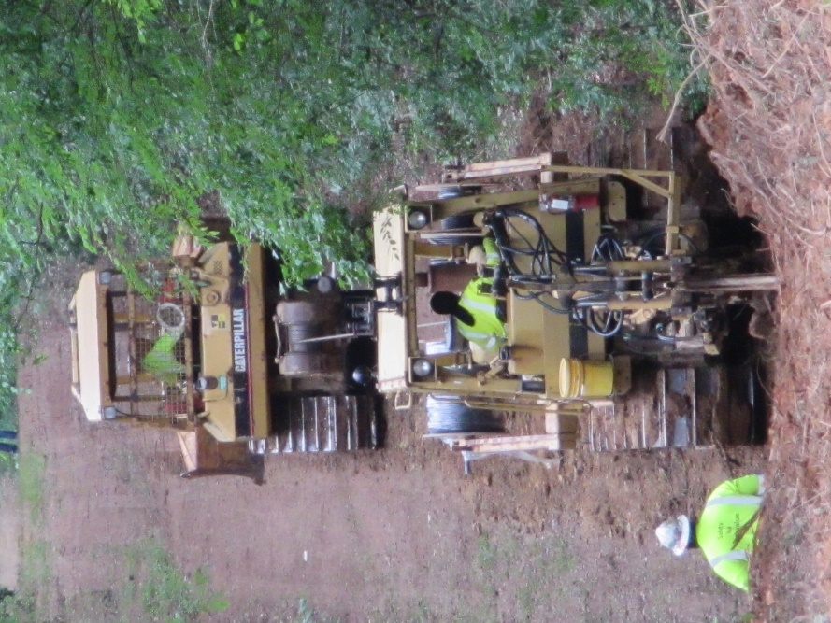Availability and location of Power: This is a key driver in the design and is important to addressing the issues of voltage drop and soil resistivity variation. The power distribution and cabling design is critical to assuring that the linear anode system is providing sufficient cathodic protection current along the pipeline length being protected.

To address these design challenges, it is essential to conduct a thorough site survey, soil resistivity testing, and engineering analysis. Collaboration between pipeline operators, corrosion engineers, and cathodic protection specialists can help develop a comprehensive and effective linear anode system design tailored to the specific cross country pipeline and its unique conditions. Regular monitoring and maintenance are also critical to verify the system's ongoing performance and to address any emerging issues promptly.

**LINEAR ANODE INSTALLATION**

Figure - Cable plow installation

Linear anodes can be installed in a variety of methodologies depending on the location and condition of the pipeline corridor. Installation methodologies include trenching/excavating, cable plow and horizontal directional drilling installations. This makes the linear anode a very cost effective installation for cross country pipelines relative to recoating.

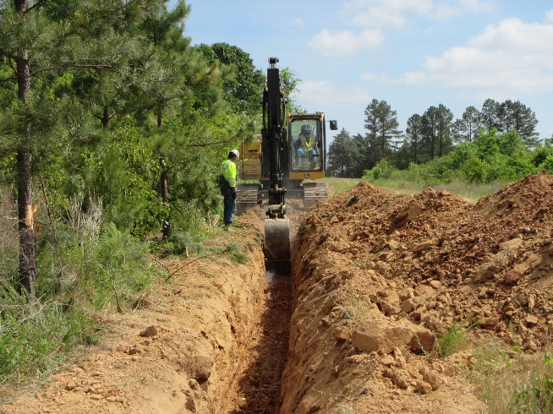The most cost effective method for installing long lengths of linear anode is with a cable plow. The cable plow can be employed to install linear anode, parallel header cables and warning marker tape with a single pass, although some locations may require a preliminary “rip” to loosen the ground prior to installing the anode with a second pass. Thorough route planning and pipeline marking is critical prior to any plowing operations to assure that the pipeline and anode installation locations are properly marked and that there is no possibility of a pipeline strike by the cable plow equipment. Cable plow operations are typically offset 2-3 meter away from the pipeline to maintain a safe working distance.

Figure - Trenching in Linear Anode

Trenching and excavating are common installation methodologies, and the use of hydro-excavation or other soft dig technology is highly recommended in congested underground areas (pipeline crossings, stations, densely populated areas, etc…) Once the trench has been excavated the linear anode is simply spooled out inside the trench and then backfilled once in place. The linear anode is a very robust anode, but care should still be taken when backfilling to avoid damaging the anode and anode continuity should be tested throughout the installation process.

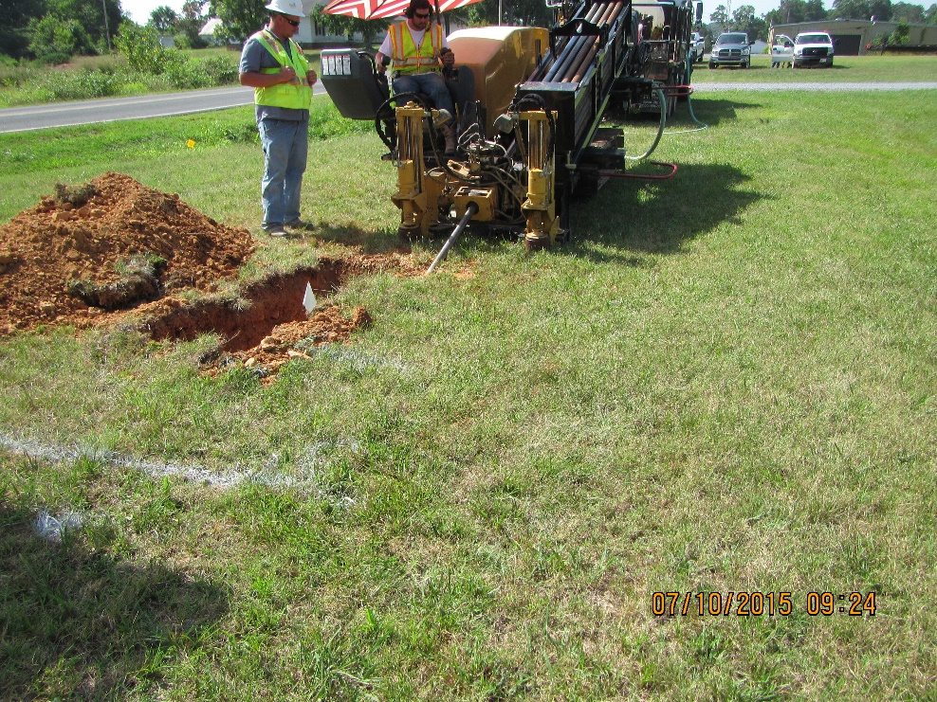

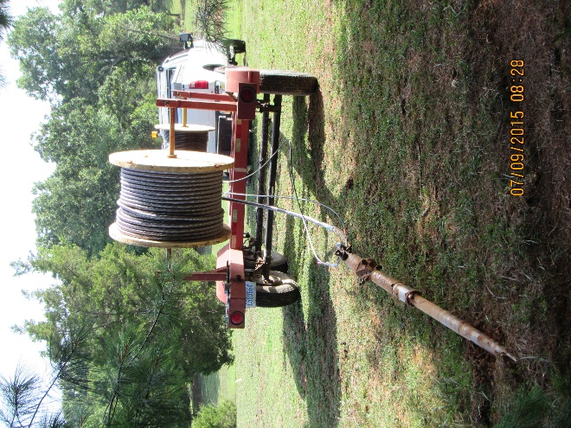

Figure - Linear Anode HDD Installation

Another common installation practice is the use of horizontal directional drilling (HDD). This technology can be used to install linear anodes in more congested environments where trenching parallel to the pipeline is not an option (under paved areas, road crossings, populated areas, environmentally sensitive locations.) The HDD technology can be used to minimize the construction footprint and impact. Linear anodes perform well in many HDD applications and specialized housings that are more robust than the fabric tube are available to increase the pulling strength of the linear anode for difficult HDD applications.

Figure - Linear Anode HDD Installation

**CONCLUSION**

Aging pipelines using asphaltic type coatings prevalent in the mid-20th century (1930s to 1980s) have not always aged well. They have generally exceeded their original design life. As these coatings fail, they shift more of the corrosion control burden to the cathodic protection systems which were originally designed only to provide secondary corrosion control. This often results in significant increases in current requirements and additional cathodic protection anode stations being installed only to find that the current is still not distributing sufficiently along the length of the pipeline. Linear anodes properly designed placed along the length of the pipeline in these areas have proven quite effective in providing effective cathodic protection distributed along the entire length of the anode installation.